Project Title: Employee’s Performance for HR Analytics

DASHBOARD:

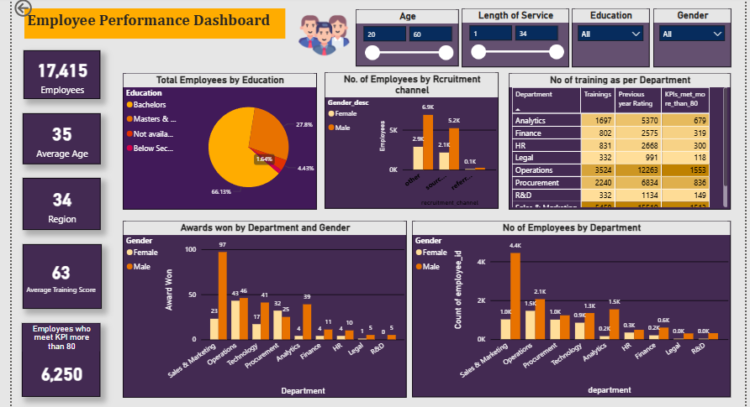

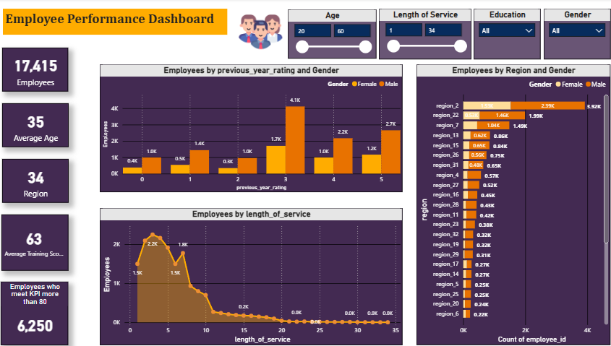

Summary:
Employee performance for HR analytics involves leveraging data to measure, analyse, and optimize employee productivity and behaviour, transforming performance management from subjective to evidence-based.
By analysing KPIs, attendance, and project outcomes, organizations can identify high-performers, address skill gaps, and improve engagement, ultimately reducing turnover and aligning workforce capabilities with business goals.

Insights:
1.Key Trends:
- Tracking specific metrics like sales revenue, customer satisfaction, and project completion rates.
- Analysing why employees, particularly focusing on "previous year rating" in key positions.
- Evaluating output, efficiency, and goal achievement.

2.Anomalies:
- Unexpected, drastic drops or spikes in an individual's output compared to their historical data or team average.
- high or low ratings compared to employee’s performance, highlighting potential bias and HR analysis.

3.Correlations:
- Strong positive correlations exist between employee satisfaction and overall organizational performance.
- A positive correlation exists between employee training.
- Relationship between Previous Year Rating and Current Performance
- Employee Performance Based on Tenure.

Recommendations:
- Establish specific goals linked to business outcomes, such as enhancing productivity, reducing turnover, or improving sales efficiency.
- Focus on key metrics that accurately reflect employee contributions.

Visualization:
- Create histograms, scatter plots, and box plots to visualize performance distributions.
- Use seaborn or matplotlib to analyse correlations between performance, tenure, and training.

Libraries Used
- Pandas: Data manipulation and cleaning.
- NumPy: Numerical calculations.
- Matplotlib/Seaborn: Visualization.

